SKINNER MS
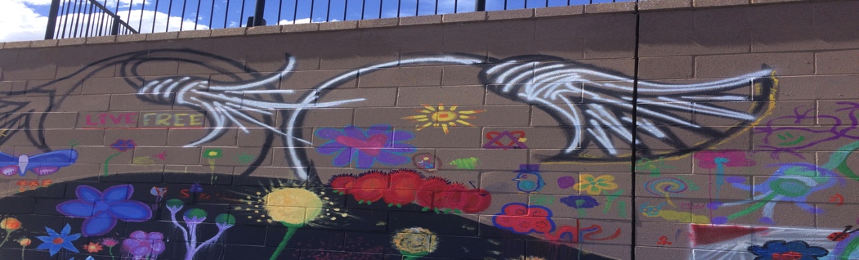
Visual Arts
Ms. Nook
laurel_nook@dpsk12.org
COURSE STANDARDS/Essential Learning

After completing this course students will have experience with a variety of visual art materials and contents (drawing, painting, mixed media, 3-D, and 2-D art). We will focus on many technical skills to help develop an aptitude in visual arts. Students will be expected to complete written evaluations and summaries (artist statement) about their projects through critique, reflection, and include ideas and sketches in their idea book. The student sketchbook is also used for the daily DO NOW and the exit slip. Students will be able to master techniques through formative and informative assessments and then apply the techniques in their summative assessment /unit projects.
Throughout this course students will use a variety of material to master visual art techniques. Students will be provided a variety of opportunities to demonstrate proficiency in each of the art standards and common core standards with special emphasis placed on 3 and 4. CREATE AND RELATE

- Observe and Learn to Comprehend: The visual arts are a means for expression, communication, and meaning.
- Envision and Critique to Reflect: Visual arts recognize, articulate, and implement critical thinking through the synthesis, evaluation and analysis of visual information.
- Invent and Discover to Create: Generate works of art that employ unique ideas, feelings, and values using different media techniques.
- Relate and Connect to Transfer: Recognize, articulate, and validate the value of the visual arts to lifelong learning and the human experience.
POLICES FOR ABSENCES AND MAKE-UP WORK: Since much of this class will be “hands-on,” student attendance and participation will be necessary toward completion of projects.

Students will be able to make-up work for full credit within two weeks of absences. Make-up work will take place outside of class time, before or after school. PIE/Office hours are on Tuesday from 3:05-4pm. Some projects with teacher approval may be completed at home.

