Unit of Study | The Elements of Art & Principles of Design |  | Length of Unit |  | 2-4 weeks
Essential Questions  Essential Questions are engaging, debatable, and require higher order thinking | 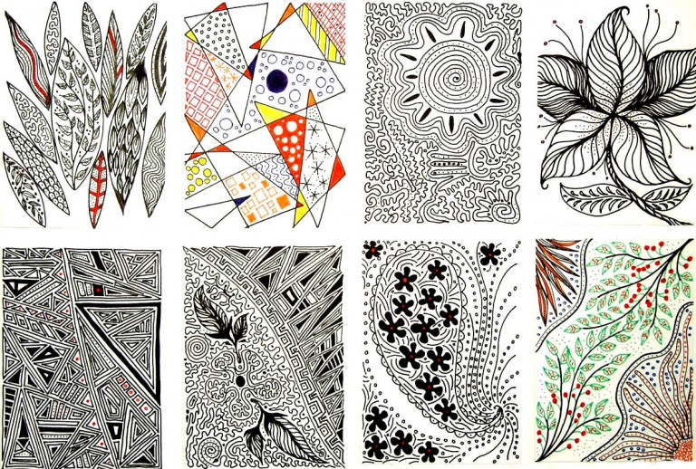  - Essential Question: How do the elements of art show expressive features in your artwork (composition)?  - Essential Question: Why is it important to know how to incorporate the elements of art in your design?  - Essential Question: How does art change our thinking?  - Essential Question  - Essential Question  - Essential Question
CLO  CLO’s for each unit should encompass all 4 Standards and connect to Evidence Outcomes | - CLO WEEK of 8/29/16  SWBAT to create artist trading card samples using the elements of art. Focusing on LINE.  INVENT & DISCOVER to CREATE  STANDARD: 3.6 Plan creation of artwork. Explore various media, materials, and techniques used to create works of art  - CLO WEEK of  Evidence Outcomes  - CLO Week of  Evidence Outcomes  - CLO Week of  Evidence Outcomes  - CLO Week of  Evidence Outcomes
LEARNING OBJECTIVES
Guiding Questions to Build Conceptual Understanding
My students Understand that… |  | Factual Content |  | Conceptual  Conceptual Questions may mirror Essential Questions
EOA and PD are related to creating a successful piece of artwork/composition. |  | Explore media, materials and techniques to create artist trading card and samples. |  | Why is it important to know how to incorporate the elements of art into the principals of design?
 |  |  |  | What are choices artists must make before beginning to work.
 |  |  |  | How do different types of line showing feeling or expressions?

EVIDENCE OF LEARNING
8/29 DO NOW: In your sketchbook or paper provided practice drawing the types of line you observed for your homework. Label the different types of line. Example: Zigzag, Diagonal, curvy. How do the different types of line make you feel?
My students will be able to (Do)… YOU DO Teacher I DO… MATERIAL PREPPED AND READY (refer to materials p. 3)
- Create…different types of line.
- Remind students Level 0: 5-8 minutes to begin Do Now/Reference CLO “what are we learning today?” I can….
- Circulate room with clipboard for checks with DO NOW and homework agenda
- Attendance
- Q&A review of Do Now and Homework assigned
- Pre-Assessment EOA and POD to gather baseline data for SLO
- Sketchbook practice demonstration for drawing different types of line. Show student and teacher examples
- Cards prepped for advanced students ready to begin after practice
- Circulate room to check sketchbook work provide feedback
- Prepare time for reflection (Student Shout Outs about strengths in work and areas of improvement)
- Demo Clean-Up and pick student tables for art jobs
- Positive reinforcements and any reminders as student exit the room for next class.
- Evaluate…their own and other student examples of line.
- Analyze…how artist think about the choices they make before creating artwork (line).
- Apply…media, materials, and techniques to create different styles of line.
- Understand…how lines could have deeper meaning in connection to
- Remember…to pick lines that have personal meaning to them.

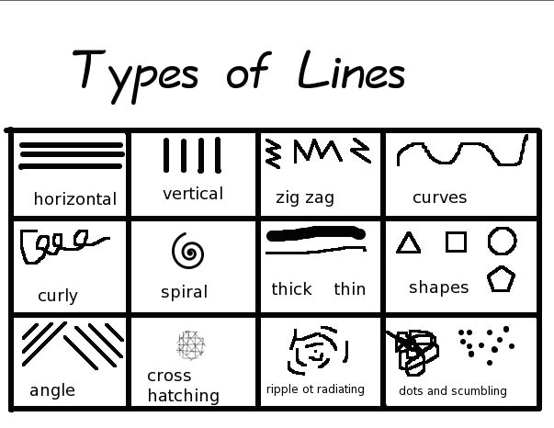

EVIDENCE OF LEARNING
Art-making Media, Skills and Techniques
My students will be able to (Do)…
Medium/Media | Materials | Skills /Techniques
Drawing | Pencil, colored pencil, and marker. | Holding a pencil to create types of line. (Ex. gesture, thick and thin line)
EVIDENCE OF LEARNING
Critical Language: Academic vocabulary to be used in oral and written classroom discourse
Grade students demonstrate ability to apply and comprehend critical language through the following examples: |  |  | CLO: SWBAT to create artist trading card samples using the elements of art. Focusing on LINE.
Academic Vocabulary | Levels 1/2 |  |  | Levels 3/4 | Levels 5/6
 | Line  Elements of Art (1-6) |  |  | shading value | gesture
AGGRESSIVE MONITORING (SEE BELOW)
Artifacts |  | Student work samples, teacher sample, circulating the room for checking in understanding.
Formative Assessment |  | Exit Slips, Daily student led mini critiques or demonstrations.
Summative Assessment |  | Project Based (Effort/Craftmanship) and Artist Statement/Critique
Rubrics |  | REFER to EOA Rubric in Core+>Art>Lesson folder
LEARNING PLAN
Accommodations Students needing academic, cognitive, fine/gross motor and sensory support will work with a partner, team or one-on-one with the teacher. Technical and research/inquiry processes can be modified for both advanced and struggling artists.
Grade 6.5: Help with fine motor, handwriting (extended time), small group work, visual cues, positive reinforcement, extended time for test or assessment.
Grade 6.4: Structured sequential approach when learning new concept or for large projects.

WE DO/Sequencing of tasks
- Do Now Practice-LINE
- Pre-Assessment for EOA and POD
- Rubric & Teacher Demo
- Continued sketchbook practice/advanced learners begin artist trading card for line
- Questions and checks for understanding
- Clean-Up and Shout Outs (Reflecting on what student learned in class related to CLO and strengths in their work for the day along with areas of improvement).
Resources
Textbooks & Curriculum
Literature (books, magazines, articles)
Artists (historical & Contemporary) | The famous quote by the painter Paul Klee “A line is a dot that went for a walk” expresses the idea of the journey and the movement from one point to the other, which creates the line.
Artworks (historical & contemporary) | http://www.widewalls.ch/line-art-famous-examples/ KLEE /WARHOL/RILEY
Denver Public Schools Online Resources | DPS Arts Webpage  Visual Arts Colorado Academic Standards  Visual Arts Connections at a Glance (Matrix)  Instructional Tools: CLOs, Units of Study, Vocabulary Index  LEAP Framework & Visual Art Appendix  Teacher Resources  Safari Montage
Technology (websites, power point presentations, Promethean presentations, interactive applications, videos) | Brain Pop website (user name and password: dpsbrainpop)

